**HTML Collection vs Node list**

• A NodeList and an HTMLcollection زي بعض إلى حد كبير

• Both are array-like collections (lists) of nodes (elements) extracted from a document. The nodes can be accessed by index numbers. The index starts at 0.

• Both have a length property that returns the number of elements in the list (collection).

• An HTMLCollection is a collection of document elements.

• A NodeList is a collection of document nodes (element nodes, attribute nodes, and text nodes).

• HTMLCollection items can be accessed by their name, id, or index number

•NodeList items can only be accessed by their index number.

• An HTMLCollection is always a live collection. Example: If you add a

<li> element to a list in the DOM, the list in the HTMLCollection will also change.

• A NodeList is most often a static collection. Example: If you add a

<li> element to a list in the DOM, the list in NodeList will not change.

• The getElementsByClassName() and getElementsByTagName() methods return a live HTMLCollection.

• The querySelectorAll() method returns a static NodeList.

• The childNodes property returns a live NodeList.

**Key Differences**

1. **Type of Nodes**:
   * HTMLCollection is specifically for HTML elements.
   * NodeList can include any type of node (elements, text nodes, comments, etc.).
2. **Live vs. Static**:
   * Both can be live or static, but HTMLCollection is typically live when dealing with methods like getElementsByTagName().
3. **Methods and Properties**:
   * HTMLCollection has methods like item(index) and is usually iterated with traditional loops.
   * NodeList has forEach() method for iteration (in static NodeList), and may include a variety of node types.

**Examples**

**HTMLCollection Example**:

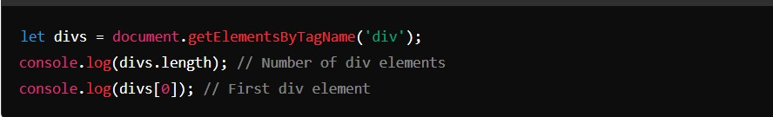

**NodeList Example**:

